**7. RESULTS**

**7.1. SCREENS**

Open MYSQL type password “**root”** next create the database systax

**🡪 Create database:** Create database “database name;” : create database bfc;

**🡪 Use The Database:** **Use “Database name” :use bfc;**

**🡪** Copy and paste **database table** details in the my sql command prompt:

create database BFC;

use BFC;

create table bfc_users(username varchar(50)primary key,password varchar(50),

contact_no varchar(12),email varchar(50),address varchar(100));

create table fileinfo(username varchar(100),filename varchar(50), fileid

varchar(50), sha_value

varchar(150), refrence_id varchar(50), start_chunk_id varchar(50), num_chunk int,

file_size long, status int);

🡪 **Select the table:** select * from table name: select * from bfc_users;

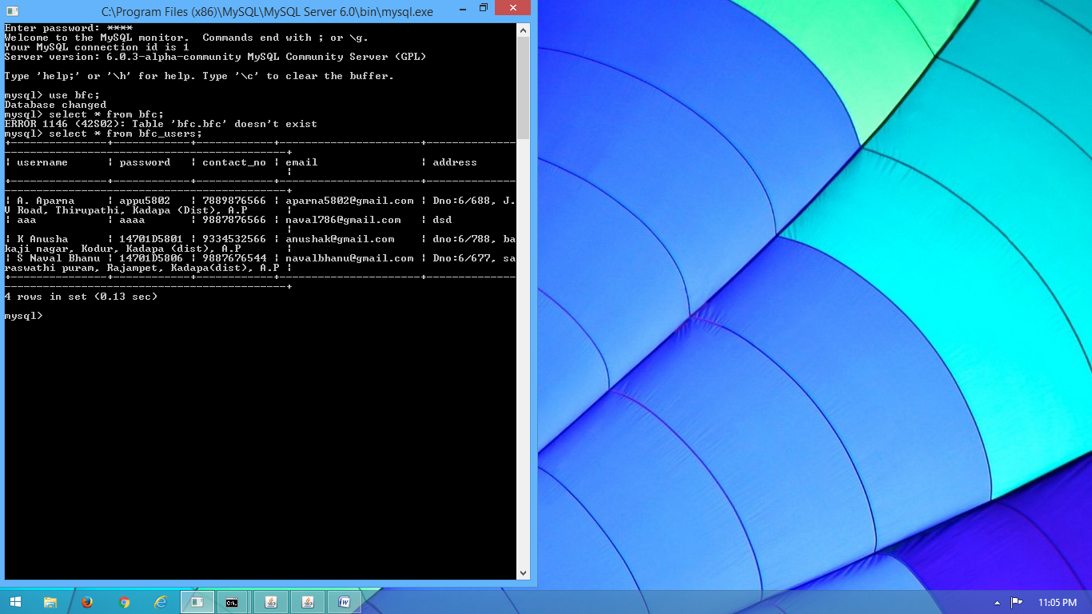

**Screen 7.1.1:** My-SQL Database Screen

**LOGICAL LAYER SERVER** 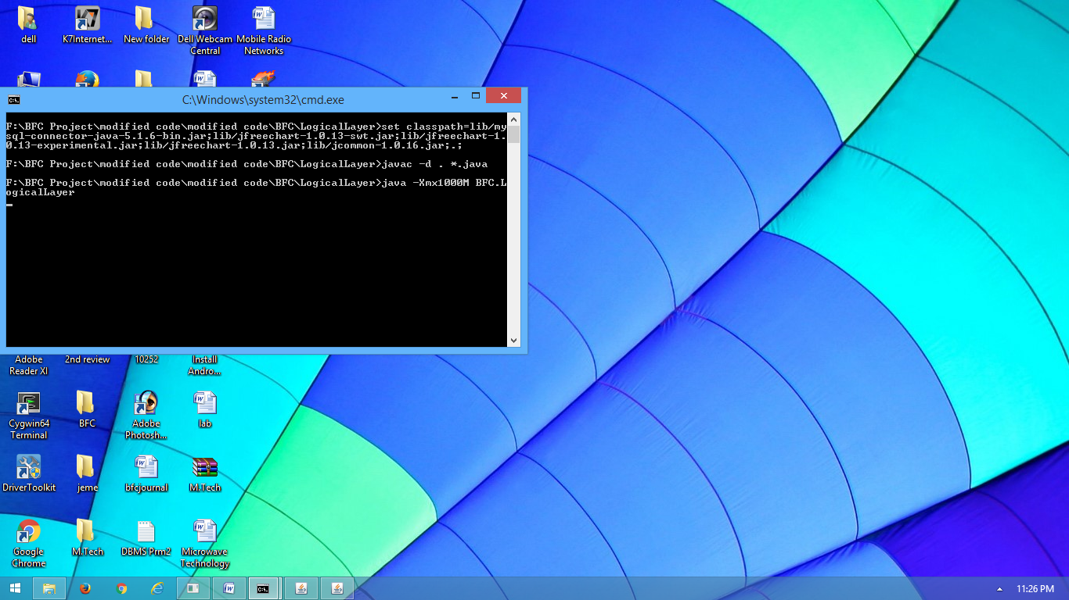

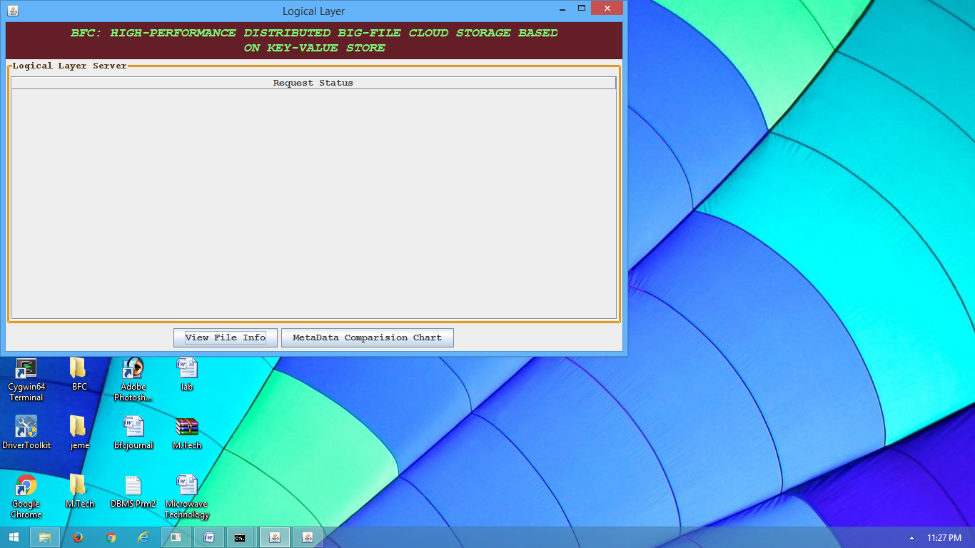

**Screen 7.1.2:** Logical Layer Screen

**Description:** Run Application Layer Server and Logical Layer server

1. **APPLICATION LAYER SERVER:**

**LOGIN SCREEN**

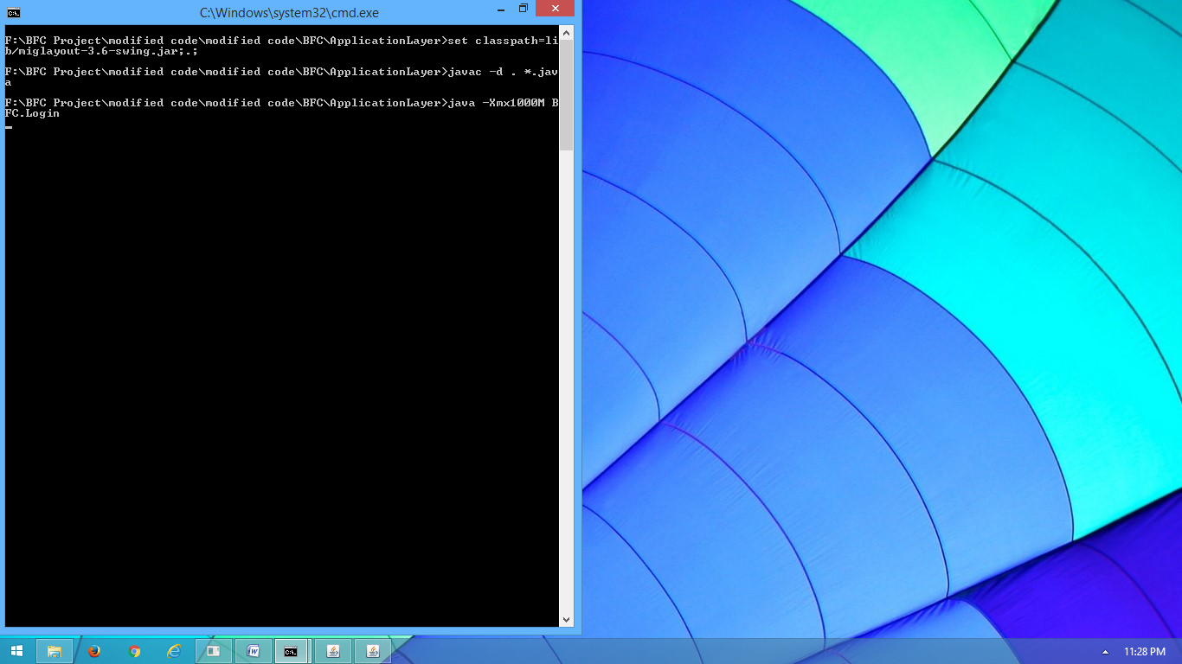

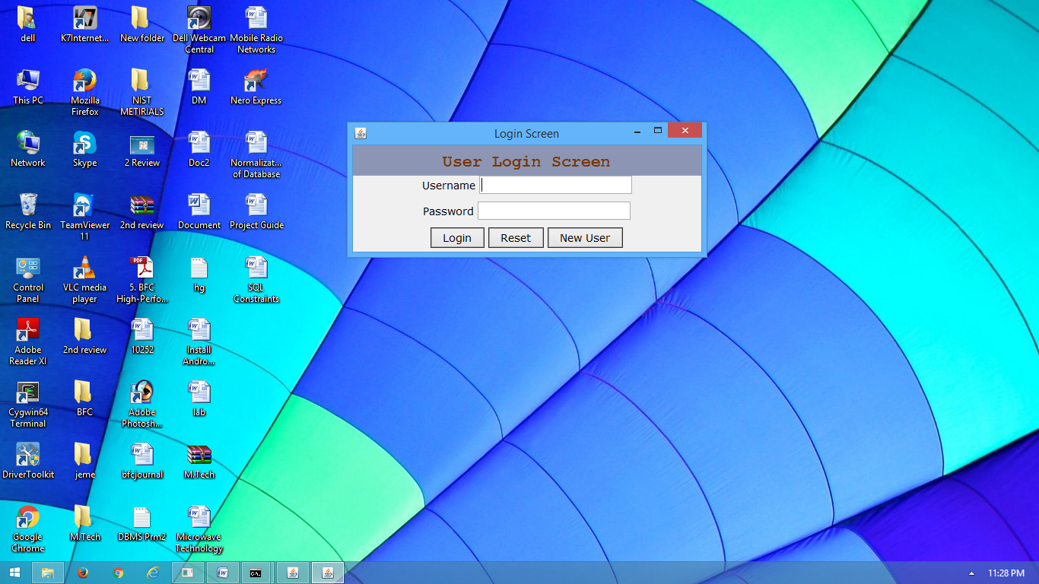

**Screen 7.1.3:** Login Screen

**Description:** This is Login Screen by using this Register the New User with required

Details.

**NEW USER REGISTRATION SCREEN**

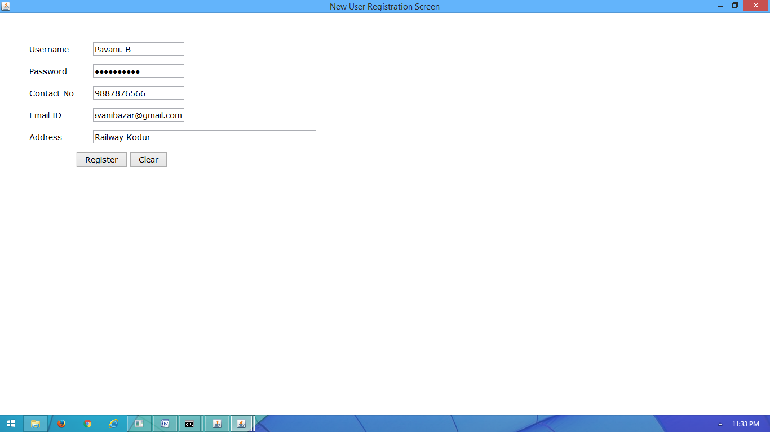

**Screen 7.1.4:** New User Registration Screen

**Description:** Register New User By entering User name and Password and other

details.

**SUCCESSFUL REGISTERED SCREEN**

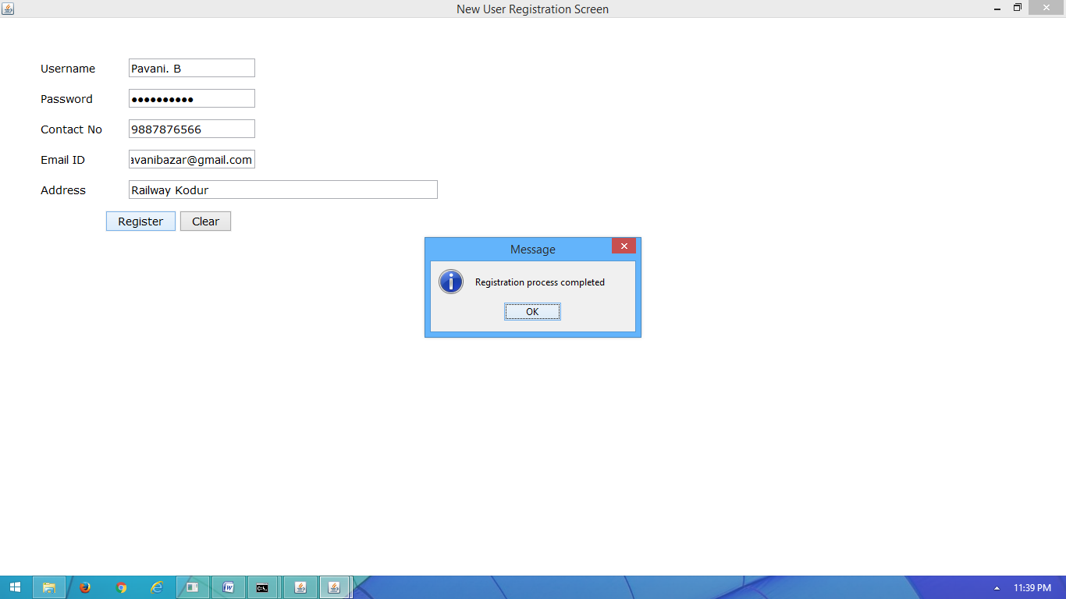

**Screen 7.1.5:** SuccessfulRegistered Screen

**Description:** After enter the values in the registration form click OK button

registration process is completed one message box is display.

**LOGIN SCREEN**

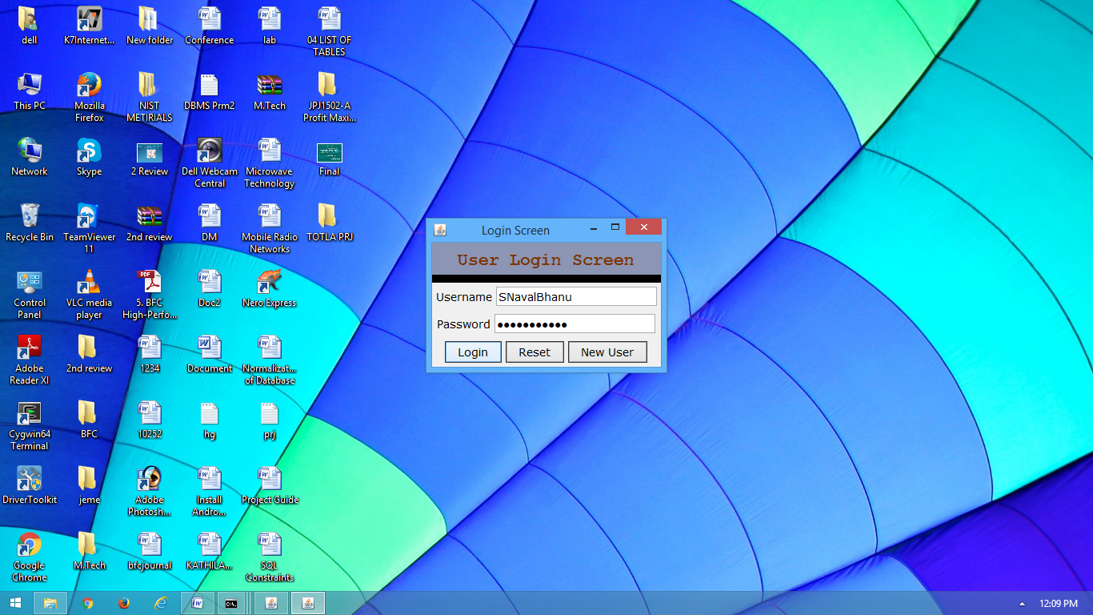

**Screen 7.1.6:** Login Screen

**Description:** Whenever Give Correct User Name and Pass Word enter into the system

otherwise error message is display. i.e Invalid User message display.

**USER SCREEN**

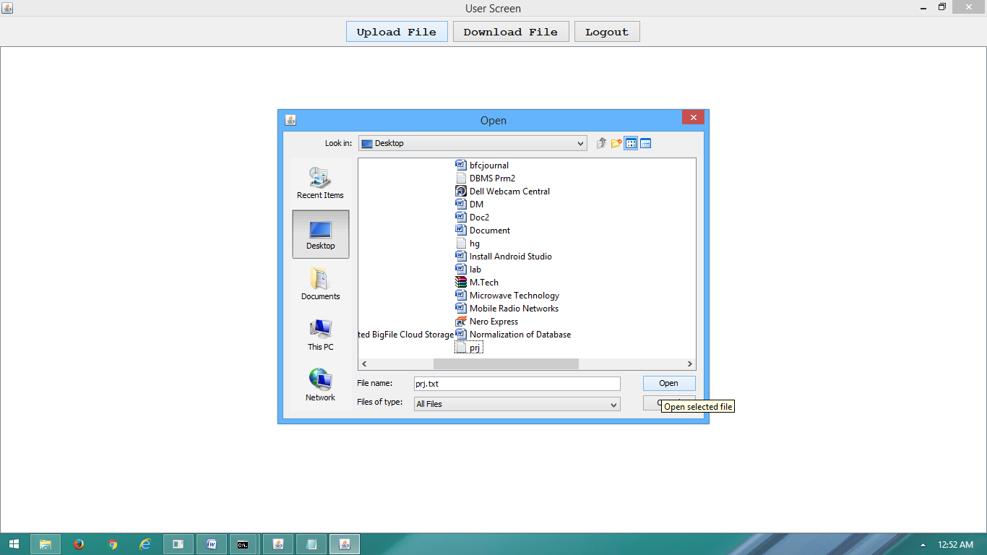

**Screen 7.1.7:** User Screen

**Description:** In the User Screen Click the **UPLOAD FILE** Button choose the file name and click OPEN , File is uploaded into the database.

**UPLOADED FILE SCREEN**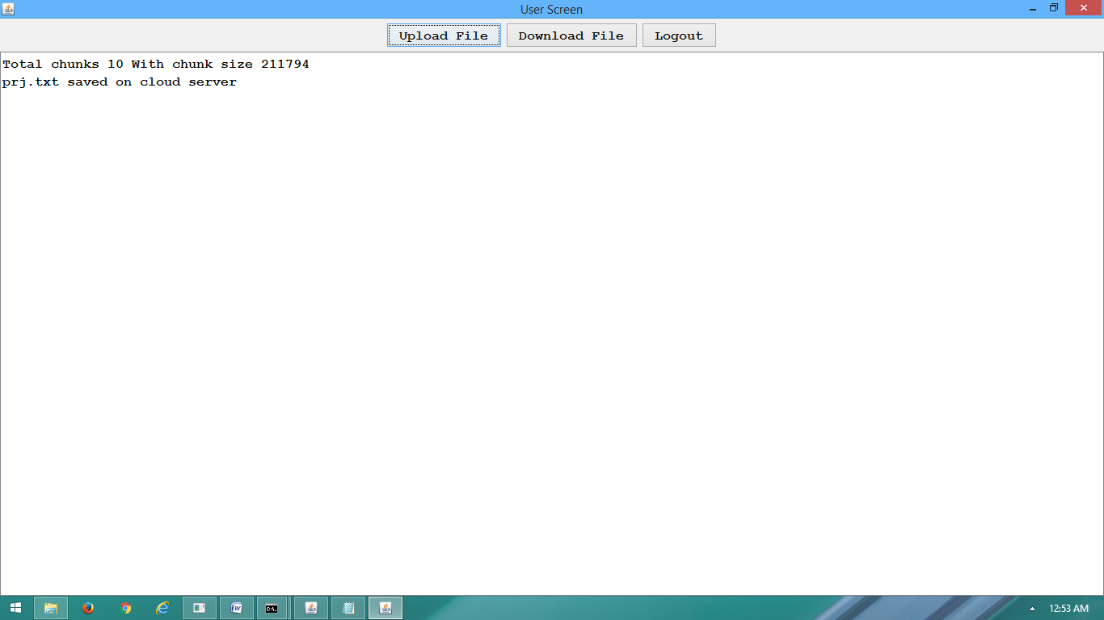

**Screen 7.1.8:** Uploaded File Screen

**Description:** File is uploaded successfully into the database. With chunks and Chunk size wise.

**DOWNLOAD FILE SCREEN**

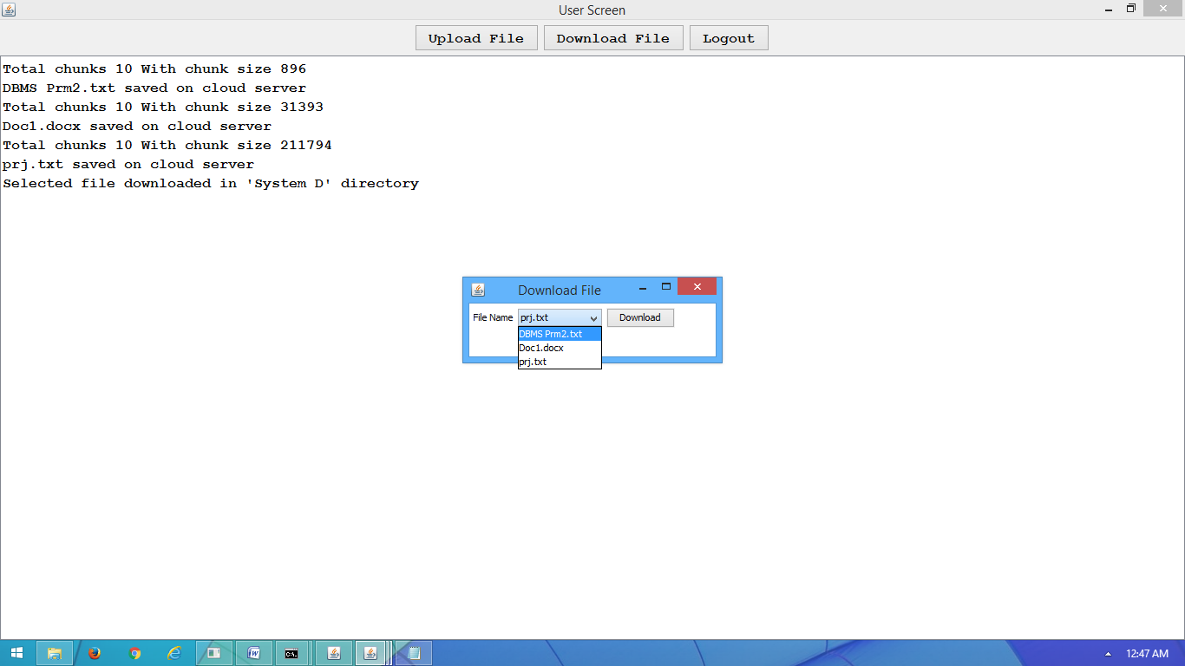

**Screen 7.1.9:** Download File Screen

**Description:** Down load the file by clicking the Down load file Button. And select files and then click Downloaded . file is Down loaded in the D:\ drive.

**VIEW DOWNLOAD FILE SCREEN**





**Screen 7.1.10:** View Download File Screen

**Description:** Open D:\ and see the downloaded file information. With the specific file name. Process is completed **LOG OUT** the system in user screen.

**LOGICAL LAYER SCREEN**

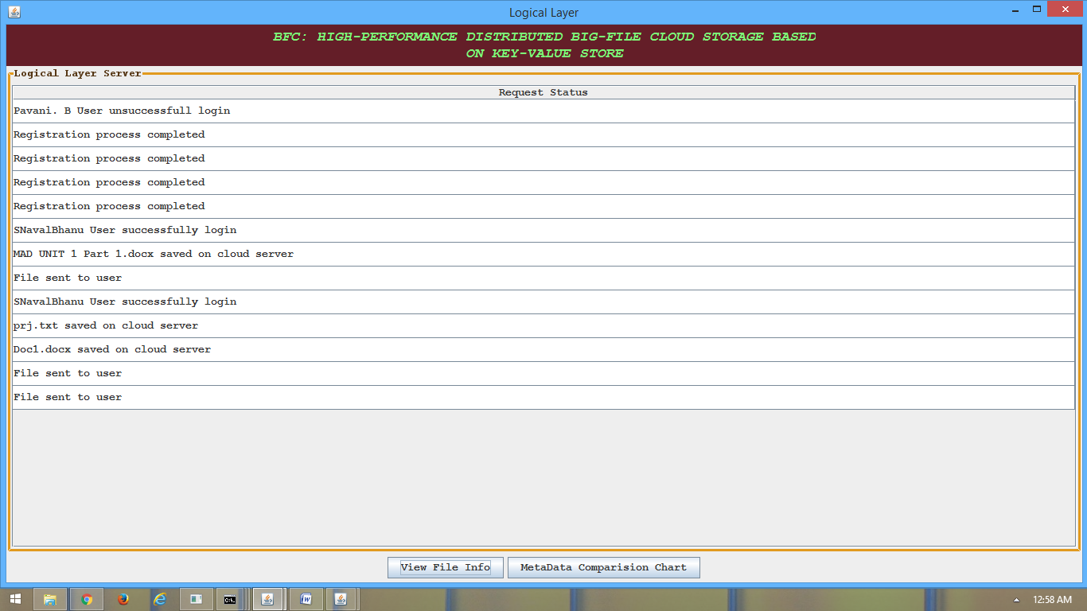

**Screen 7.1.11:** Logical Layer Screen

**Description:** In the logical layer screen identify the successful registered user details and Down load file details .

**VIEW FILE INFORMATION SCREEN**

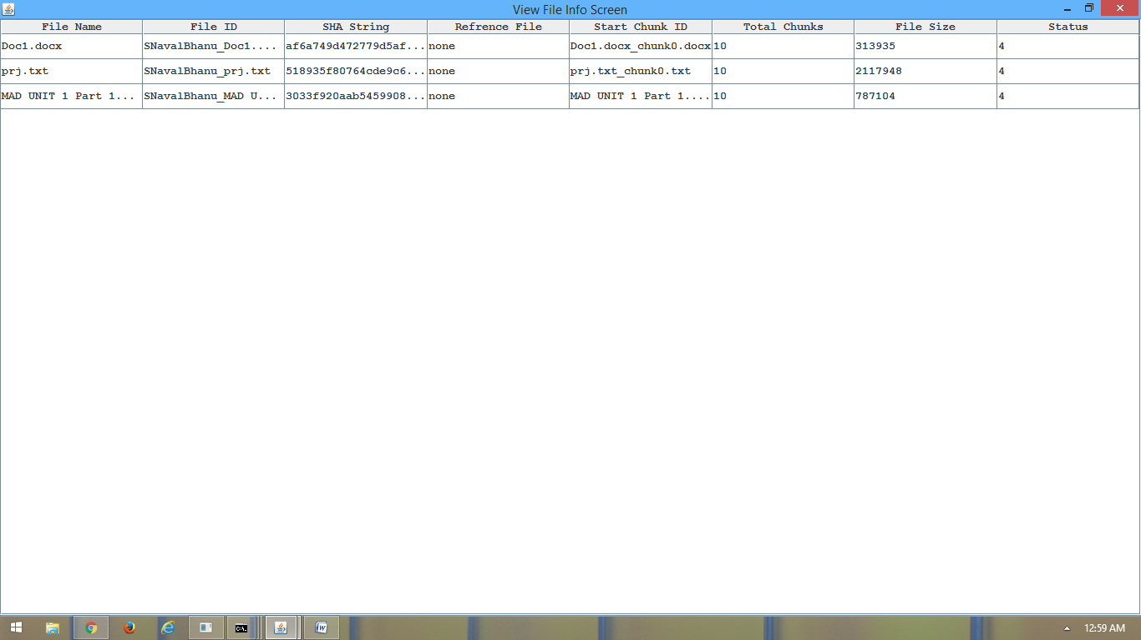

**Screen 7.1.12:** View File Information Screen

**Description:** By clicking View File Info button Open the view file info Screen in this see the downloaded file information.

**FILE DATA COMPRESSION CHAT SCREEN**

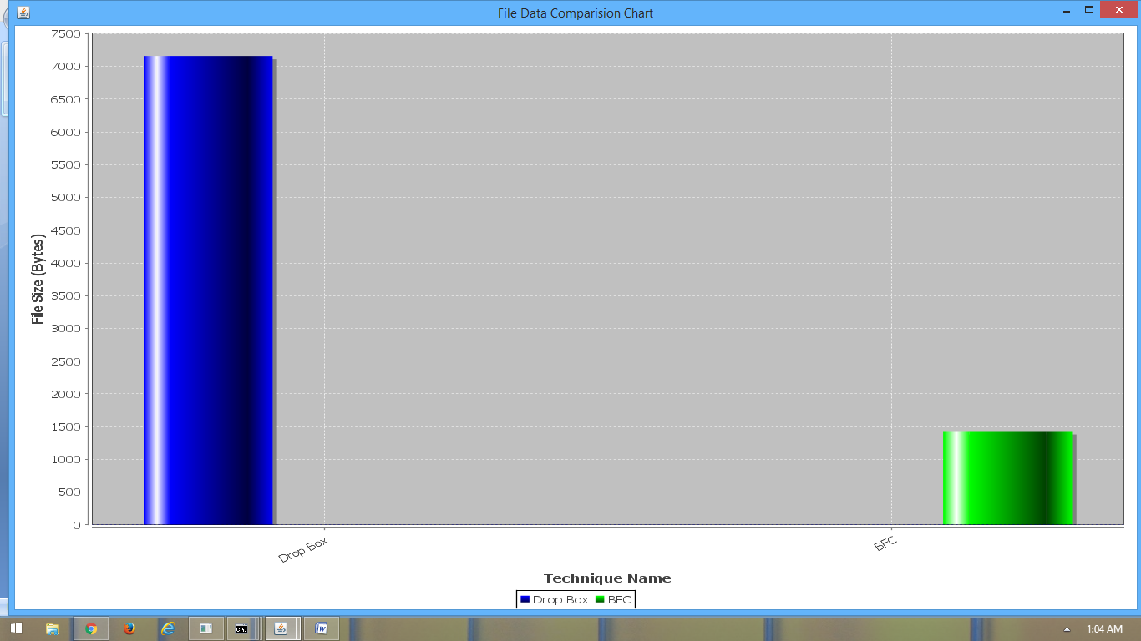

**Screen 7.1.13:** File Compress Chat Screen

**Description:** By clicking the META DATA COMPRESSION CHAT button open the **File Data Compress Chat screen** in this identify the difference how to store the data in normal cloud storage engine and BFC file.

**OUTPUT SCREEN**

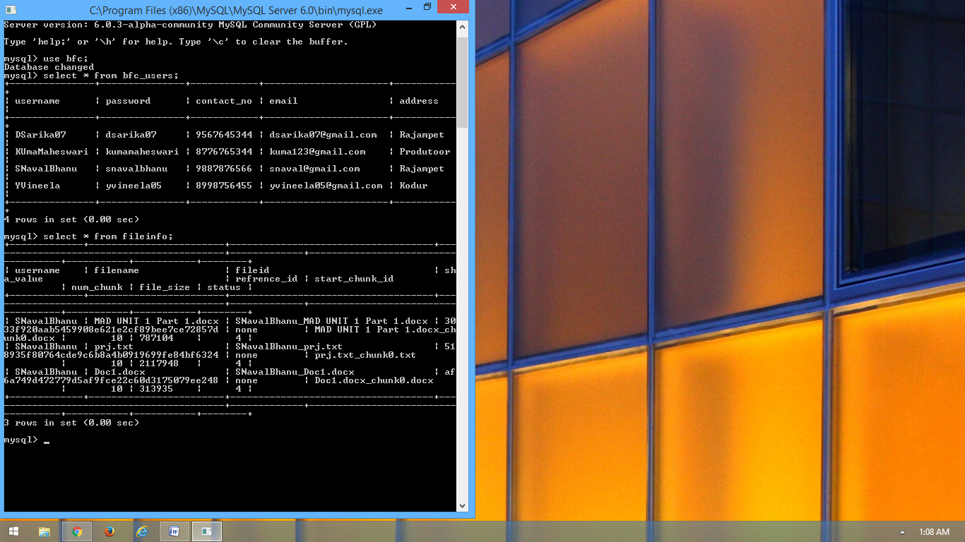

**Screen 7.1.14:** Output Screen

**Description:** In MYSQL database Store all the file information in the database.